OGSM Chart
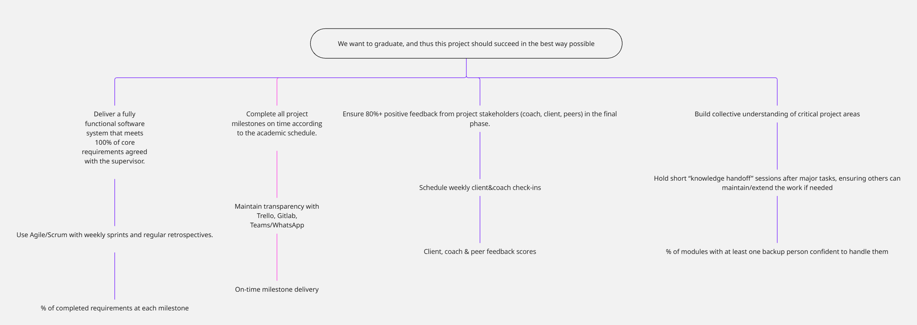
Figure 1 OGSM Chart

Groupmembers
Sepideh Qorbani, Furqan Malik, Faezeh Kianimoravej, Ben Vos

Description & Motivation
The presented OGSM outlines the structured approach our team will use to ensure the successful completion of our master’s software engineering project. The Objective is clear: to graduate by delivering a high-quality software solution that meets academic standards and stakeholder expectations.
Our Goals translate this ambition into measurable outcomes: delivering all core requirements, completing milestones on time, gaining positive stakeholder feedback, and fostering a shared understanding of critical project areas. These goals ensure the project balances technical delivery, process discipline, and collaboration.
To achieve them, we defined Strategies focused on proven practices in software engineering: using Agile/Scrum with regular sprints and retrospectives, ensuring transparency with collaboration tools, maintaining stakeholder engagement through frequent check-ins, and promoting knowledge sharing through structured handoff sessions. These strategies not only support timely delivery but also strengthen resilience against risks like knowledge silos and miscommunication.
Finally, our Measures provide concrete indicators of success, such as the percentage of completed requirements, milestone adherence, stakeholder feedback scores, and backup knowledge coverage across modules. This ensures that progress and quality are continuously tracked and adjusted where necessary.
Overall, this OGSM provides both a roadmap and a monitoring framework, helping our team stay aligned, accountable, and prepared to deliver a project that supports our graduation and future professional growth.

Personal goals

(Part 2) Everyone takes the above part, and adds personal goals (you do not have to share them with the other team members, but of course it could help you if you do). The goals should relate to PS&L, so no technical goals or something like 'Learning Dutch'. There should be items where the teachers team can validate if you improved during the year. Probably there is a connection between the group-goals and your personal goals. Describe that. If you write down a lot of things, choose max three items and set them as most important. To help you think about the goals, here is a set of questions:

which role do you (not?) take in a group. Is that what you want? How does it help to achieve the personal/group goals?
how can you make your environment more organised? Or how do you get time from the others for creativity and deep thoughts about the best solution?
how can you make sure you are heard when you have something important to say? How can you message your opinion or thought in an effective way?
how can you improve by making use of others, listen better or just observe them?
ChatGPT can ask you lots more questions that could help you.
Try to keep this last page concise, between half a page and a full page. I you would like to discuss anything with me, mark it in the text with something like a red marker.

Summary
Submit a document that contains the visual output of the goals session (page 1), some extra explanation about the goals and steps (page 2), and the last page your personal reflection and personal goals.

